1. Click new/Edit test button, then click any settings tab and click back button and again click add/edit test button previously selected setting tab is displayed. It need to display the “Basic Settings” tab.
2. In Test page, test created person name is not displayed and it was empty.
3. In basic settings, after enter valid details and click save button, tab should immeditaley move to next tab(Question manager tab), but it only moves after the pop up is closed.
4. In question manager, after add a topic and click delete button, Text need to change as “Are you sure want to delete this question from question manager?” or any other valid message. And also need to improve the size of the text and the text should present in a single line only.
5. In question manager, after add a topic and click delete button, Heading should need to change as “Delete topic” not as “Delete question setup”.
6. In question manager,In topics, every details are aligned in left side, need to align in center both heading and content.
7. In question manager,After enter valid details and click save button and again redirect to question manager, time values are displayed as zero.
8. In Time setup, after enter valid details and click save button, “Something went wrong” error pop up is displayed.
9. In Test Access, every details are aligned in center, but proctor details are displayed as left alignment and need to change into center alignment.
10. In Test Access, in second column heading name need to change as “Candidate name” current name is “User Name”.
11. In Certificate template, need to improve the alignment.
12. In certificate template, Advanced programming test name should change as selected category name.
13. In Question manager, in time tab need to mention the format and unit.
14. In Test setup, extra space is displayed.

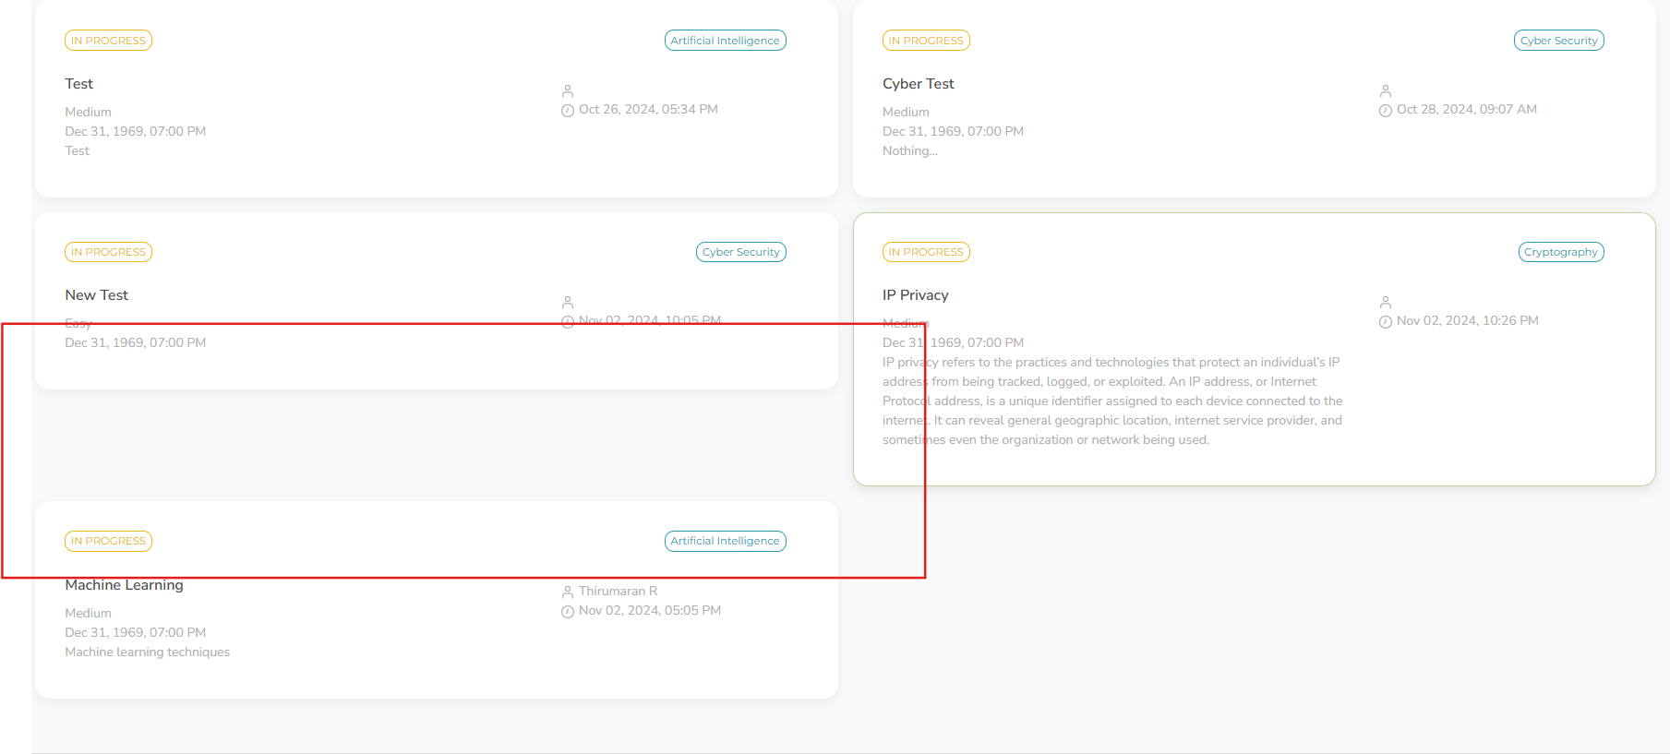

1. In Question manager,After enter valid details and click clear button, In add topics , topic value is not cleared.